**Project: Woodson Park Academy & YMCA-ELC**

**Week Ending: May 22nd, 2020**

**THIS WEEK:**

* Masonry and Brick continues at WPA
* MEP Overhead continues at WPA
* Framing continues at WPA
* Steel at YMCA continued
* Exterior sheathing at YMCA
* Site Sub working on LL site utilities
* Drywall on Main and 2nd levels
* Window Frame install at WPA
* COA inspections – delays occurring due to COVID-19 action

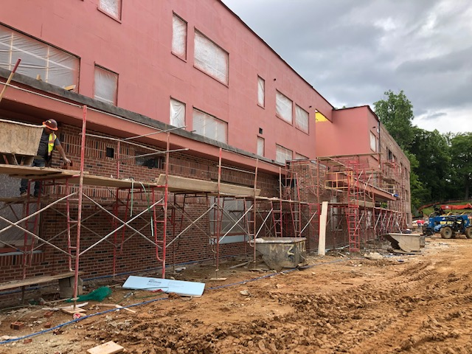 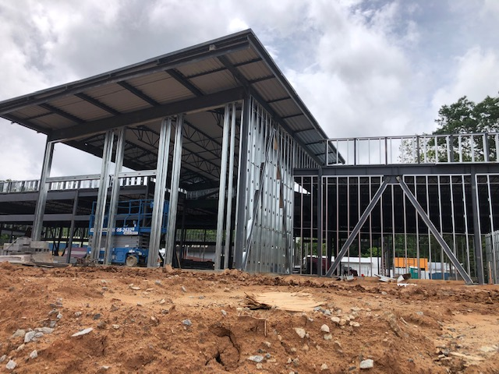

Brick at lower side of Main level Exterior Framing at YMCA

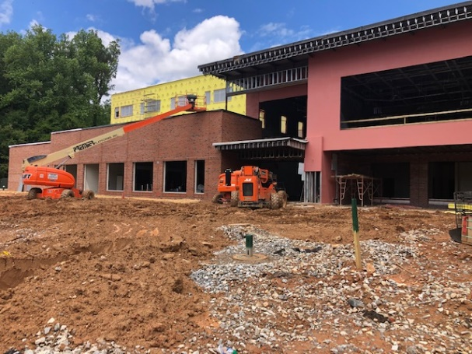 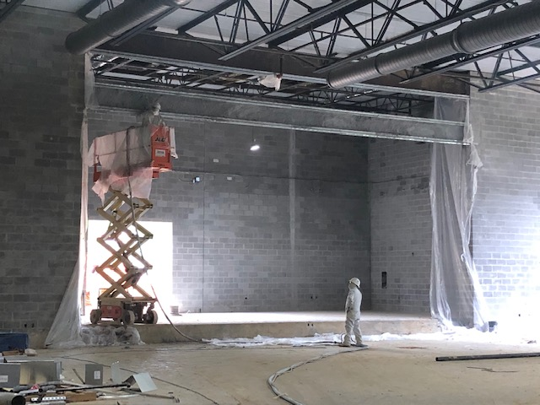

West Elevation at WPA Fireproofing at Gym / Stage area

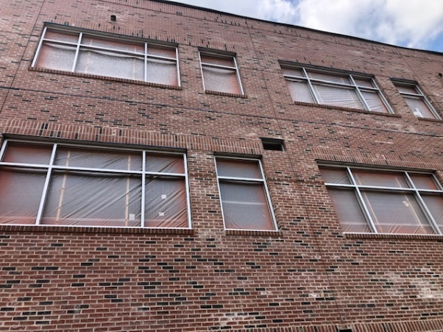 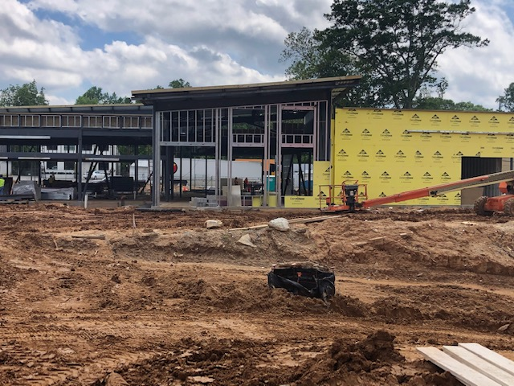

Frame installation at the WPA North Elevation at YMCA

**NEXT WEEK – May 25th thru May 29th:**

* Masonry and Brick continues
* MEP Overhead continues
* Framing continues
* Drywall on Main and 2nd level continues
* Storefront Frames and Glass install to begin at WPA
* LL Utilities continue
* Window Frames and Glazing continues at WPA
* Structural Steel at YMCA continues
* Exterior Framing and Sheathing at the YMCA
* COA inspections – delays occurring due to COVID-19 action

**PAYMENT STATUS:**

* Gmp#1 $3,703,488.00
  + Paid to date amount $2,129,067.57
* GMP#2 $27,034,273.00
  + Paid to date amount $8,523,875.14
* GMP#3 $5,877,688.00
  + Paid to date amount $0.00
* GMP#4 $1,974,712.00
  + Paid to date amount $0.00

**WEATHER:**

* Total of 1-1/4” of rain for the week

**SCHEDULED DATE OF SUBSTANTIAL COMPLETION**

* WPA – November 4, 2020
* YMCA-ELC - December 3, 2020

**PREPARED BY:**

* **Matt Dauber, Carroll Daniel Construction Co.**